Domayne’s Steel Outdoor Dining Set

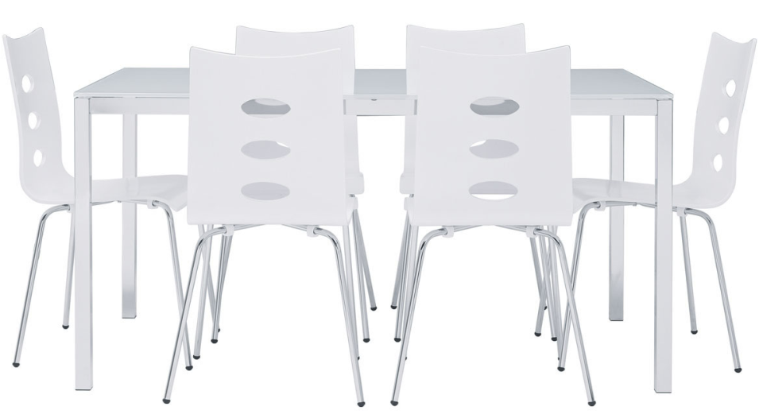

|  |
| --- |
| **DESCRIPTION** |
| Domayne introduces stylish steel outdoor dining set with a rich metallic finish the set of tables and chairs is perfect to create the perfect look out doors. The rich steel of the dining set is perfect for weather conditions. Perfect for family night out and does not expand with change in temperature. |

|  |  |  |
| --- | --- | --- |
| **Price** | **1400$** | |
| **Dimensions** | **Table H** x **W** x **L** | **41in x 35.5in x 59in** |
| **Chairs H** x **W** x **L** | **30in x 16in x 20.5in** |
| **Features** | **Six Chairs and One Table with white reflected paint so that you don’t feel warm during the summer** | |
| **Finished** | **Reflector Paint** | |
| **Available in** | **White Only** | |